Chapter 2: Cycles in Ecosystems
Section 2.2 Cycles of Matter

Pollution in the Environment

- Pollution occurs when a substance is added to the environment at such a fast rate that it cannot be broken down, stored or recycled in the air, land, or water in a non-damaging form.
- Pollution can also cycle through the ecosystems.

- Pollutants are substances that cause pollution.
- Pollutants cannot be broken down, stored, or recycled in the environment in a way that is not damaging.

- Bioaccumulation is the process in which a substance builds up in a living organism from the surrounding air or water, or through the consumption of organisms that already have the substance that is being accumulated.
- Killer whales are the top consumer in a food chain that usually includes phytoplankton, zooplankton, and salmon.
- The top consumers in food chains are affected most by bioaccumulation.
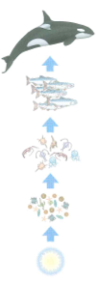
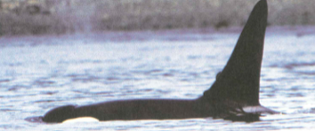

Using the handout with information from page 49 of the science textbook please complete the following sentences.

The killer whale lives in the ocean off the coast of
southern ____________________________________.
It is the _______________ consumer in the food chain. Pollutants in the water can enter the food chain at any _____________________ but they often enter through organism that are _____________ on the food chain.
The pollutant is passed along and concentrated in the tissues of the next organism in the food chain. Therefore the amount of pollutant _________________ at each level in the food chain. As a result the __________ consumer in the food chain ends up with a very _________ amount of pollutant in its body.

