There are a set of native totem animals for each of the 12 moons of a year and we carry them with us throughout our lives. We share our basic dispositions with the basic characteristics of these totems. We can learn everything about ourselves by studying these birth month animals.

Goose or Snow Goose Birth Totem
Date of birth: February 22 to January 19
Stone: Quartz or Peridot
Determination and Resourcefulness: Persevering, determined, and ambitious to a fault, the Goose Totem sets goals for accomplishment, and always obtains them.

Otter Birth Totem
Date of birth: January 20 to February 18
Stone: Turquoise
Joy – Primal Feminine Energy: Otters awaken curiosity. They remind us that everything is interesting if we look at it from the right angle.

Wolf Birth Totem
Date of Birth: February 19 to March 20
Stone: Turquoise or Jade
Teacher – Pathfinder: Wolf is the pioneer, the forerunner of new ideas, to teach and share with others what they have learned. Wolves have an enormous sense of family as well as a strong individualistic urge.

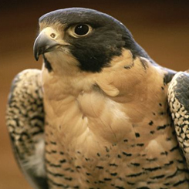

Red Hawk or Falcon Birth Totem
Date of Birth: March 21 to April 19
Stone: Fire Opal
Mental Speed – Agility – Focus: A natural born leader, those with a Falcon Totem are always looked upon for clear judgment in sticky situations.

Beaver Birth Totem
Date of Birth: April 20 to May 20
Stone: Jasper, Bloodstone
Dream Builder: Beaver is the builder of the Animal Kingdom, and has a strong sense of family and home.

Deer Birth Totem
Date of Birth: May 21 to June 20
Stone: Moss Agate
Gentleness – Innocence: The Deer is lively, quick-witted and always aware of her surroundings.

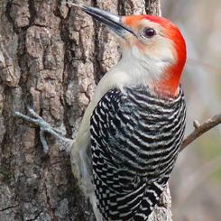

Woodpecker Birth Totem
Date of Birth: June 21 to July 21/22
Stone: Carnelian Agate
Sensitive – Emotional – Protective: Birth Totem Woodpecker is the most nurturing of the animal symbols, the consummate listener, totally empathic and understanding. The primary focus for Woodpecker is to be completely devoted to another, even at the expense of the self.

Salmon or Sturgeon Birth Totem
Date of Birth: July 22/23 to Aug 21/22
Stone: Garnet
Wisdom – Inner Knowing: Salmon, despite strong river currents, will always return to the place of its creation. Its determination is driven by the wisdom of instinct and inner-knowing, which yields a sense of purpose that cannot be stopped by outside forces. Salmon tells us to trust our gut feelings and inner-knowing.

Brown Bear Birth Totem
Date of Birth: August 22/23 to September 21/22
Stone: Amethyst
Keeper of Unconscious Knowledge: Bear teaches us that to accomplish the goals and dreams we carry enter the silence within. If we choose to believe that there are many questions to life, we must also believe that the answers to these questions resides within us.

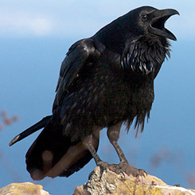

Raven or Crow BirthTotem
Date of Birth: September 22/23 to October 22/23
Stone: Jasper
Keeper of Sacred Law: Crow knows the Unknowable Mysteries of Creation and is Keeper of All Sacred Law. This Totem signifies first-hand knowledge of a higher order of right and wrong than that indicated by Human Law. Crow see the physical and spiritual world, ( as humanity interprets them ) are an illusion and can simultaneously see the past, present, and future. Crow merges the light and darkness, seeing both inner and outer reality.

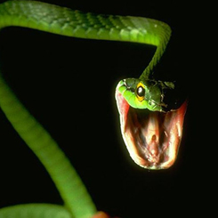

Snake Birth Totem
Date of Birth: October 23/24 to November 21/22
Stone: Malachite
Wisdom – Healing – Symbol of Eternity: The shedding of Snake’s skin symbolizes the transformation of the life-death-rebirth cycle. They are compelled toward evolution and transformation, driven to discard the past and emerge with new ‘flesh’. It is the energy of wholeness, cosmic consciousness and the ability to experience anything willingly and without resistance.

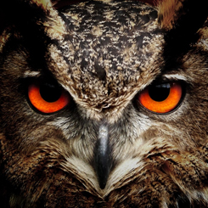

Owl Birth Totem
Date of Birth: November 22/23 to December 21
Stone: Obsidian
Magic and Wisdom: Owl is a symbol for wisdom, because Owl can see what others cannot. No one can deceive the Owl about what they are doing, no matter how hard they try to disguise or hide it from the Owl.
source: squidoo.com

