1.3 Roles of Organisms in Ecosystems
All organisms have a role in their ecosystem.
A niche is both the space where an organism lives and the role it plays within its ecosystem.

Producers
- Producers are organisms that can make their own food using non-living elements in their environment.
- Many producers, such as plants, make their own food through photosynthesis, a process by which plants use water, carbon dioxide, and sunlight to produce sugars (food).

Consumers
- Consumers are organisms that eat other organisms for food energy.
- Animals cannot make their own food, so they are consumers.
- Consumers depend on producers for their food.
Herbivore: a consumer that eats plants only (e.g. cows)
Carnivore: a consumer that eats other animals (e.g. lynxes and dolphins)
Scavenger: a consumer that eats already dead animals (e.g. vulture)
Omnivore: a consumer that eats both plants and animals (e.g. Me)

Scavengers And Decomposers
- Scavengers are organisms that eat decaying plants and animals.
- Decomposers are organisms that break down dead or waste materials, such as rotting wood, dead animals.
- Decomposers don’t bite/chew food.
- Decomposers release chemicals onto dead plant or animal that breaks down the tissue. Then the decomposer absorbs the nutrients into its own cells.
- The nutrients return to the environment when the decomposer dies.
- Fungi is an example of a decomposer
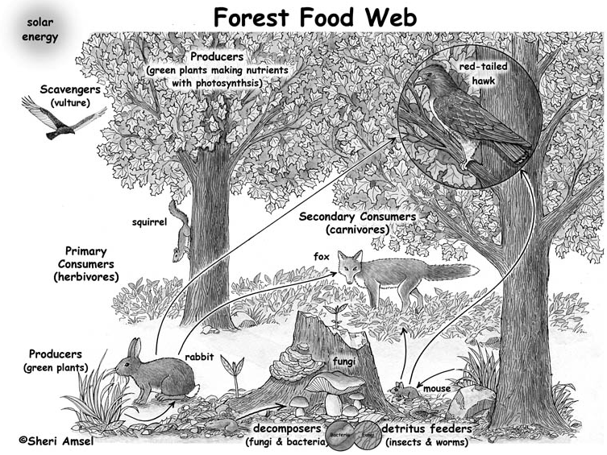
Primary consumers (1st): herbivores that eat the green plants (producers)
Secondary consumers (2nd): carnivores that eat the animals that eat the plants
Tertiary consumers (3rd): larger carnivores that eat the secondary consumers

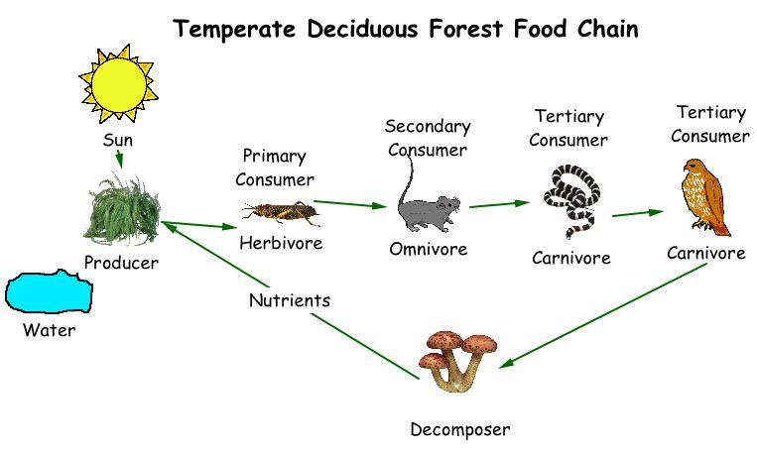

1.3 Living Relationships
Symbiosis is when two species live closely together in a relationship that lasts over time. There are three main types of symbiotic relationships.

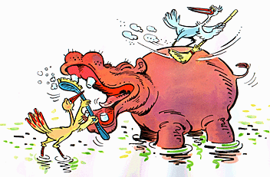
1. A mutualistic relationship is when two organisms of different species "work together," each benefiting from the relationship.
E.g. Mutualism occurs between the oxpecker (a kind of bird) and the rhinoceros or zebra. Oxpeckers land on rhinos or zebras and eat ticks and other parasites that live on their skin. The oxpeckers get food and the beasts get pest control.

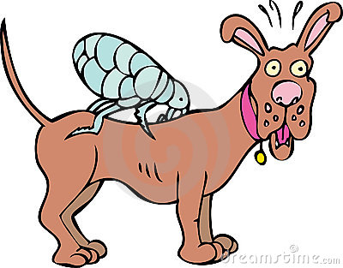
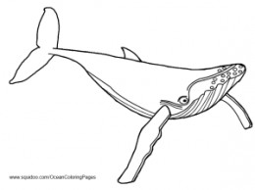
2. Parasitism is a symbiotic relationship between two different organisms, in which one partner benefits from the relationship, while the other partner is harmed. The partner that benefits is the parasite. The parasite lives on or in the other organism, the host, and feeds on it.
E.g. Flea on a dog

3. Commensalism occurs when there is a relationship between two different organisms, in which one partner benefits, while the other neither benefits, nor is harmed.
E.g. Barnacles on whales’ back

