Carte de recette – LA PIZZA

CONTENT

1. Title (le titre)
- Type of pizza needs to be included in the recipe title
- Title should be printed/typed larger than the other text on the recipe so that it stands out as the title

2. Utensils/Appliances (les ustensiles de cuisine):
- Minimum of 5 utensils mentioned or used

3. Ingredients (les garnitures):
- Recipe card includes a minimum of 5 ingredients
- Correct French spelling

4. Directions (les directives):
- Numbered steps, listed in the correct order (sequential)
- Includes a preheat oven step with the required temperature the oven should be set at, as well as the duration of time pizza must remain in the oven
- Specific instructions (minimum of 5 different pizza preparation verbs)
- Correct spelling of French vocabulary words and verbs
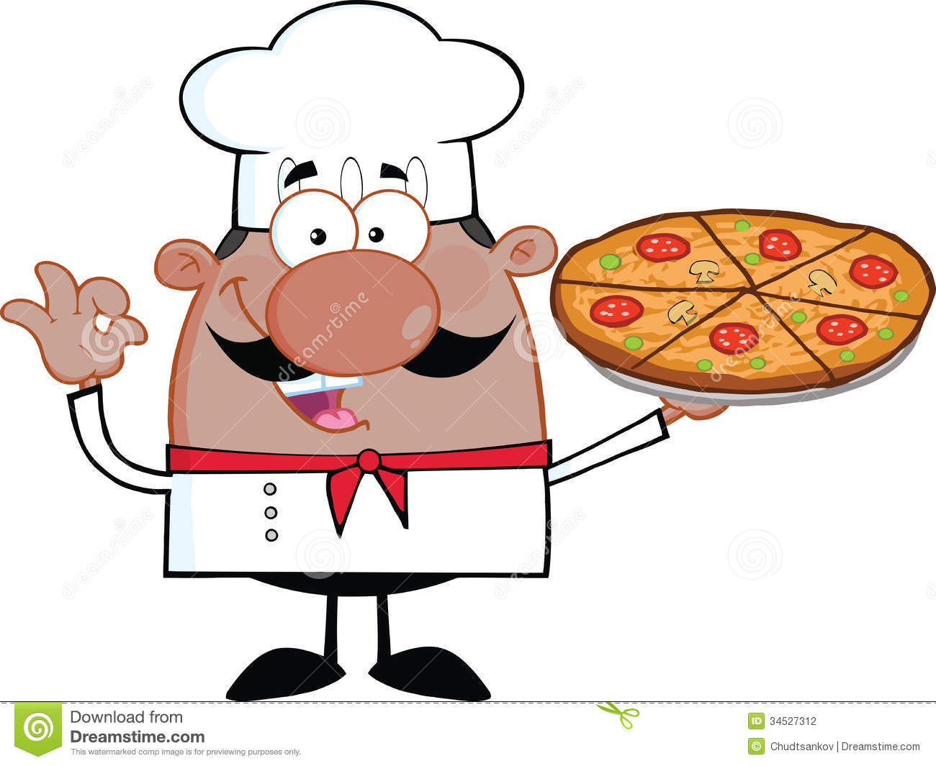
Additional information/requirements
- Bake time
- Serving size information (portions)
- Drawing that fits the pizza theme (fine lined and coloured)
- Student’s name

PRESENTATION

- Evidence of effort and care (fine lined and neatly coloured and/or decorated)
- Correct spelling, grammar, and punctuation (French verbs and vocabulary)
- Easy to follow instructions and understand the steps to be taken
- Follows the layout of a typical recipe card (ingredients listed, sequential order of required steps, etc.). Evidence that student has look at examples and taken into account the format of a recipe.
- Includes all required content (listed above)

Example:

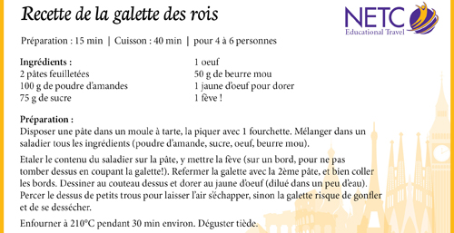
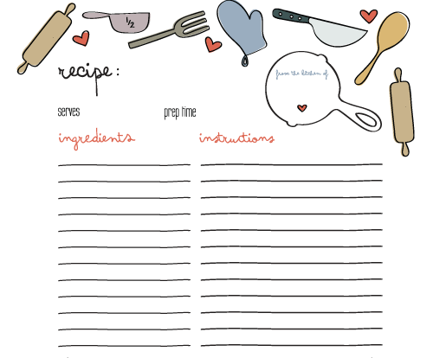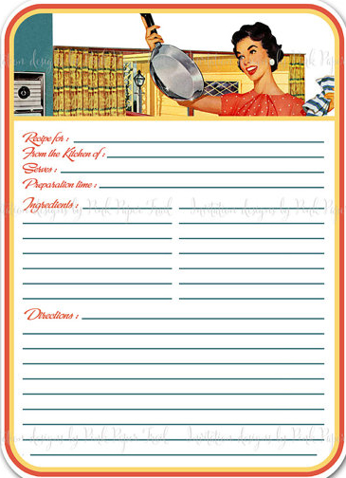
Additional Vocabulary
une assiette - plate
les ustensiles de cuisine - kitchenware
la cuisine - kitchen
le frigo - refrigerator
un couteau - knife
une cuillère - spoon
une table - table
une planche à découper - cutting board
un doseur - measuring cup

http://www.happychild.org.uk/freeway/french/vocab/kitchenitemsoverview.htm

