Chapter 2: Cycles in Ecosystems
Section 2.2 Cycles of Matter

- Unlike energy, many types of matter are used over and over again by living systems; they are cycled through the environment
- Two important cycles are: (1) the carbon cycle and (2) the water cycle

The Carbon Cycle
- Plants use energy from the sun to convert water and carbon dioxide into foods (photosynthesis)
- These foods contain the carbon from the carbon dioxide.
- As one organism becomes food for the next organism in the food chain, the carbon containing materials are passed along.
- When organisms use the food for energy, the carbon in converted (transformed) back into carbon dioxide and is available for plants to use again.
- The carbon cycle shows how carbon is used over and over again.

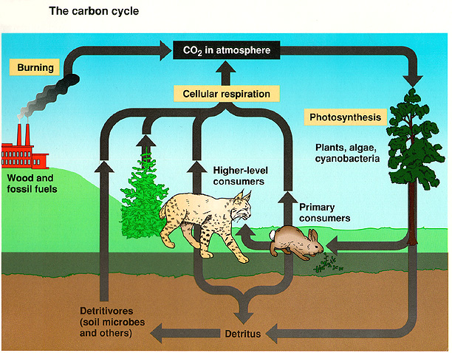

- The amount of carbon in the environment doesn’t change; it is used over and over again by organisms.
- Not all the carbon in plants and animals is converted back into carbon dioxide immediately.
- When organism in oceans and lakes die, their tissue often drift to the bottom and form a thick layer of carbon-containing materials. These materials are covered with sand and silt and buried.
- After millions of years, under a lot of pressure the carbon-containing materials are converted into coal, oil, and natural gas.
- When people burn coal, oil and natural gases for fuel, the energy is released and the carbon is converted into carbon dioxide. This also contributes to the carbon cycle.
Chapter 2: Cycles in Ecosystems
Section 2.2 Cycles of Matter

The Water Cycle
- The water cycle is the continuous movement of water through the environment.
- There are four main processes in the water cycle:

1. Evaporation: Process in which liquid water changes into an invisible gas called water vapour. Evaporation is when the sun heats up water in rivers or lakes or the ocean and turns it into vapour or steam. The water vapour or steam leaves the river, lake or ocean and goes into the air.

2. Transpiration: Process in which water that is taken in through a plant’s roots evaporates from the plant’s leaves, stem and flowers.

3. Condensation: Process in which water vapour in the air changes back to tiny droplets of liquid water when the air cools. The droplets of water are so small that they remain suspended in the air as clouds or fog.

4. Precipitation: Process in which the tiny droplets inside clouds combine to form large drops. Precipitation occurs when so much water has condensed that the air cannot hold it anymore. The clouds get heavy and water falls back to the earth in the form of rain, hail, sleet or snow.

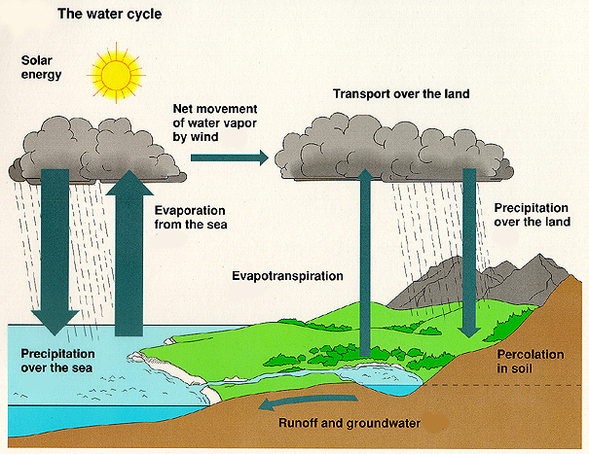
Ground water is the water in the soil. The roots of plants can grow down to reach the ground water. People can reach ground water by digging wells.
Run-off is the water that runs along the surface of the ground into lakes and rivers.

