Section 2.1 Food Chains, Food Webs, and Energy Flow

Food Chain
- A model that shows how food energy passes (flows) from organism to organism.
- Food chain begins with a source of energy (usually the sun).
- Plants trap energy from the sun and convert it into a form that can be stored in food.
- Animals eat the plants to obtain this energy.

In a food chain the arrows show the direction in which the energy flows from organism to organism.

Producers in Food Chains
- Plants and phytoplankton in food chains are producers.
- Producers can make their own food because they contain chlorophyll.
- Chlorophyll is a green chemical that traps the energy of the sun.
- Photosynthesis: process where producers use the trapped energy to make food.
- During photosynthesis the trapped energy is used to convert carbon dioxide gas and water into foods such as sugar and starch. As a result of photosynthesis, oxygen gas is released back into the air.

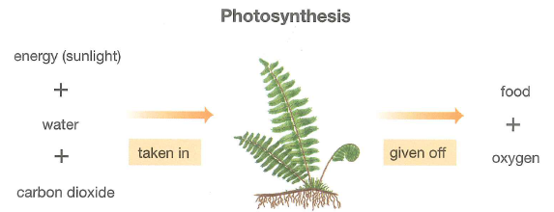
Consumers in Food Chains

- Consumers follow (come after) producers in a food chain.
- The carnivore at the end is known as the top consumer.
- A consumer’s only source of energy is producers or other consumers.
- A consumer gets the energy it needs by breaking down high energy foods, such as sugars and starch, in process known as cellular respiration.

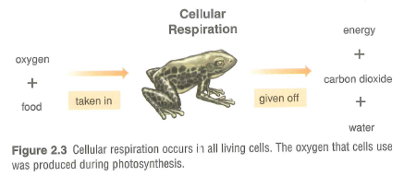

- Cellular respiration occurs inside all living cells.
- During cellular respiration, oxygen is used to help break down the high energy foods.
- Carbon dioxide water and energy are released.
- This energy is used to carry out all functions of life, such as growing repairing tissue, breathing, and digestion.

Food Webs
- A food web shows the network of interconnected food chains in an ecosystem.
- A food web is more realistic than a food chain because it shows the feeding relationships in ecosystems.
- Producers are usually eaten by many different consumers.
- Most consumers are usually eaten by more than one kind of predator.
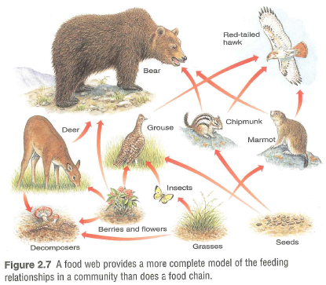

Pyramid of Numbers

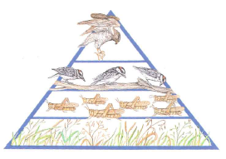
- Pyramid of numbers shows how many organisms are at each level in an ecosystem.
- Pyramid of numbers includes the same organisms that are in the food chain, but the size of each level shows the number of organisms involved.
- There are always a large number of producers at the bottom and fewer organisms at the top.

Energy Flow
- The transfer of energy that begins with the sun and passes from one organism to the next in a food chain.
- Only a small amount of energy is stored in the body tissues because most of it is used for life processes.

